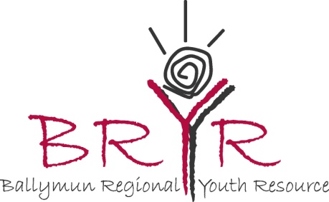
EVS in Ballymun Regional Youth Resource
Recruitment for EVS Project, 4th Sept 2016- 30 July2017

- Name:

- Contact Details:

Address
Email
Phone number
Skype address
( if known at this stage)

- Are you aged between 23-30?

- Describe your interest/experience in working with young people.

- Please describe what interests/ skills/experience you have that are suitable for areas of this role.

- Please describe your experience/ability to share those interests/skills with young people.

- Please outline the qualities you would bring to the role.

- Please outline why you are applying for the role of European Volunteer with the Ballymun Regional Youth Resource?

- Please add in any other comments that you would like to share.

- Who is your sending organisation?
My Sending organisation is Scambieuropei. The cultural association Scambieuropei was founded in 2009 by two Italian guys, motivated by the positivity of their international experience. The association has created and operates the portal www.scambieuropei.info to offer young people new opportunities for European mobility across jobs, scholarships, internships, volunteer work and intercultural exchanges.
The association Scambieuropei want to give a solution to the lack of information in this field through a platform where young people can find easily and free opportunities to develop their personal and professional skills in a European perspective.

