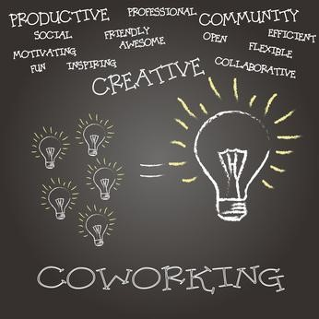

“Feedback is coming”

23rd February to 3rd March of 2017
Iscar -Spain-

Key Action 1: Learning Mobility of Individuals

“Feedback is coming” PROJECT
Youth Exchange
23rd February to 3rd March of 2017

PROJECT DETAILS
Project name: Feedback is coming
Project dates 23rd February to 3rd March of 2017
Place: Iscar / SPAIN Number PIC : 948839160
Organization: Association Deses3
Participants: 50 Participants in the project will belong to 6 different countries: Norway, Spain, Italy, Romania, Portugal and France.

The organizers:
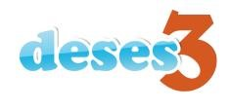

Association DESES 3, we are an organization that works with youngsters in their Total Care Education giving priority to those who are disadvantaged because of unemployment or cultural, social and economical grounds, providing spaces and projects to help them to develop useful social skills and inclusion ideas.
We work different topics according to the aims and goals to achieve.

- Participate in Programs and Awareness Development Cooperation with the Third and Fourth World.
- Organize and disseminate actions related to training and information on Health and Prevention.
- To inform, sensitize and manage programs, projects, courses and activities related to the environment, both in its protection, defense and training and information dissemination and education and enjoyment.
- Develop activities such as courses, seminars and training days at Leisure and beyond.
- To contribute to the integral development of people, especially those who present the biggest difficulties (social, cultural, economic, physical, mental, origin...), helping to fully realize their physical, intellectual and social potentials, as citizens and members of the Local Community and / or Regional.
- Develop actions and Social Intervention and Integration Programs.
- Develop Activities, Classes, Camps, Youth Exchanges, Tours, Travel, with and for children and young people in the area of Formal and Non- Formal Education.
- Develop all the activities as Free Time activities and Non Formal Education
- To promote activities, programs, projects and integration activities and fight for the incorporation of immigrants into our society.
- Develop proposals and actions on gender equality, providing positive support to the women, and promoting their inclusion and an equal participation in our society.

Facebook page: https://www.facebook.com/asociaciondeses3/
Website: http://asociaciondeses3.wix.com/asociaciondeses3
Twitter: @3Deses
E-mail: europalmente@outlook.it

PARTICIPANT COUNTRIES AND ASSOCIATIONS:

COUNTRY | NAME | WEB
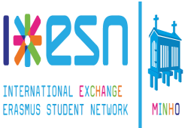  PORTUGAL | Associação Erasmus  Student Network Minho | www.esnminho.org
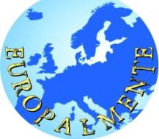  ITALY | EUROPALMENTE | http://europalmente.tk/
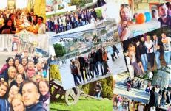 RUMANIA | Asociatia Dare to take your chance  (DTC) | https://www.facebook.com/daretotakey ourchance/?fref=ts
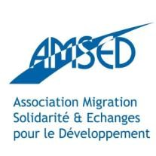 FRANCE | AMSED | www.amsed.fr
NORWEY | Olsvik sokn | http://olsvik-kirke.no/

SUMMARY

”Feedback is coming”, we propose the most example of how an action plan for democratic and civic participation as that of Medina 21, typical of the town Medina del Campo, and with 10 years of existence since its inception, has managed to be recognized not only as a model of real, possible and above all authenticated participation in the town of Medina del Campo, where you can raise your idea of how you want from the smallest of its inhabitants nationally but internationally next park games that will be built next to his house, to the most largest of the inhabitants with its view of where it should go implanted the new home for the elderly in the population and that services should have.

Feedback is coming, proposed that the young participants in this project, know this sharing system since its inception, knowing firsthand by City Council technicians, collaborators and facilitators own project that initiated the plan Medina 21 her participation bodies, projects created and applied in its existence, its strengths and weaknesses, ultimately a clear example of participation where fixed and can implement similar patterns of participation in their catchment areas / country with the help of their public or private actors closer.

The language of the project will be English.

Working Methods
Our Youth Exchange will be non-formal learning. It means that learning is based on your experience, your motivation and your needs. During the exchange, non-formal education methods and methods that assure balance between theory and practice will be used such as presentations, group works, workshops, games, role plays, exercises etc.

NEEDS
- 8 participants per country (Norway, Portugal and France).
  - 7 young people aged 18-30. o + 1 leaders no age limit.
  - Participants need to be aged over 18 years old.

ROMANIA and ITALY have a participant less.
TOTAL 7 Participants (6 young people aged 18-30 + 1 leaders no age limit).

- Your task during the exchange:
  - Presentation of your country and your organization. o Information about the situation of the main topic in your country context. o Traditional foods and drinks for cultural night.
  - Flag of each country would be great.

If you find more participants interested in participating in the total number that corresponds to your country, we invite to that you make a list of participants on hold according to the criteria that we establish, because not always you can ensure the participation of the total number of participants in the event that any participant has some unexpected last minute.

PARTICIPANT’S PROFILE

- Youth participants of sending organisations, active youth workers and youth information workers.
- Capable of speaking, writing and understanding English at least at the medium level;
- Interested in the main topic of the exchange;
- Capable and willing to develop further projects.

TRANSPORTATION
Arrival: Madrid Airport, 23rd of February (before 15:00 pm, please confirm your flight details). Departure: Madrid Airport, 3rd of March (After 13:00 pm).
You should take a flight to Madrid airport, because it is the main airport near our region and you will find planes from your country easily. About transportation from the airport we will inform you after collecting all participants’ flights information, because we normally pick participants up at the airport and bring you directly to our project place all together. We hired a private bus for all participants from Madrid airport to the hostel of Iscar.
You should take a flight to Madrid airport, because it is the main airport near our region and you will find planes from your country easily. About transportation from the airport we will inform you after collecting all participants’ flights information, because we normally pick participants up at the airport in one private bus and bring you directly to our project place all together.
The reasons for this private bus are:
- No regular Bus to Iscar at all hours.
- The cost of a private bus is much cheaper for each participant and it is much more confortable, that a public bus trip. You can Check this yourself.
The cost of this private bus per participant is 15 €. This price include travel go and return to the airport, 2 visit to the cities of Medina del Campo and Salamanca. We believe that is a more than fair price for all these trips.
This 15 euros are not include in the travel cost because it is private (European Commision rules).
Iscar is a small town in northwest of Spain. It has about 8 000 inhabitants. It is located just 160 km from Madrid and 45 km from the historical city of Valladolid. It is famous for being one of the most important cities during the Spanish medieval times, has a very well preserved castle from XI century. It is also well known for riding bulls with horses during its festivities.
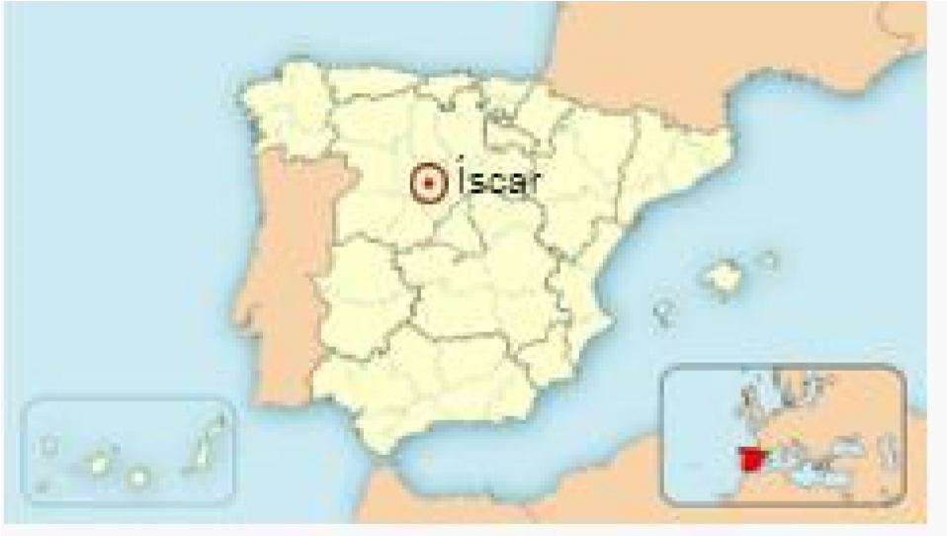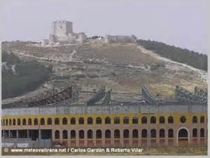

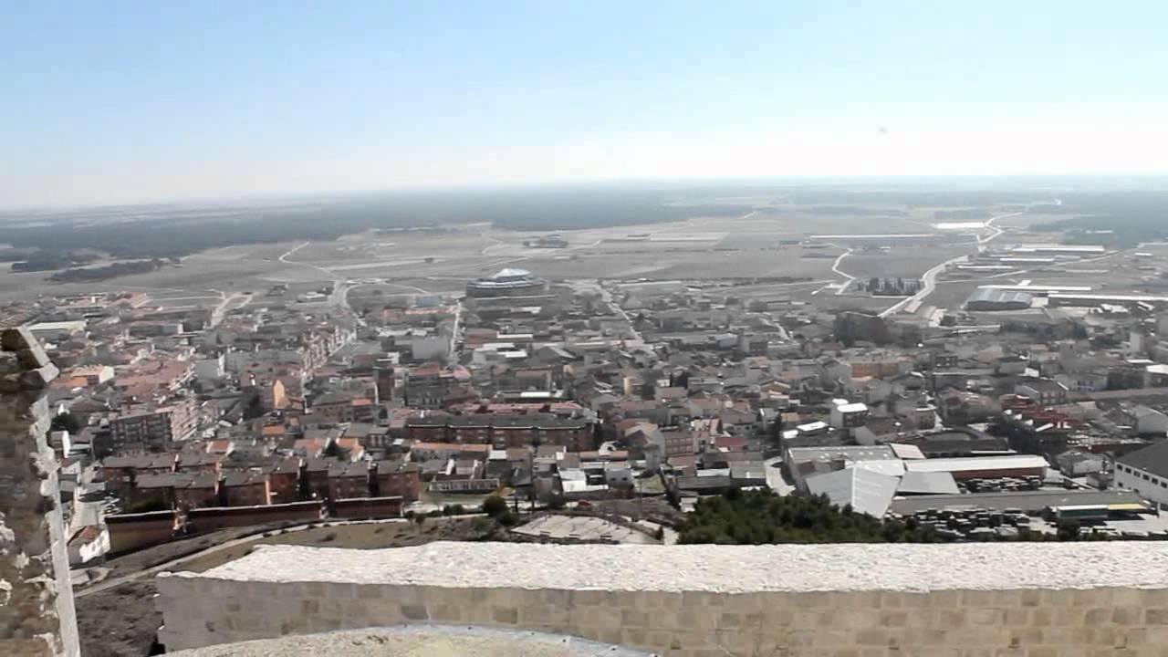

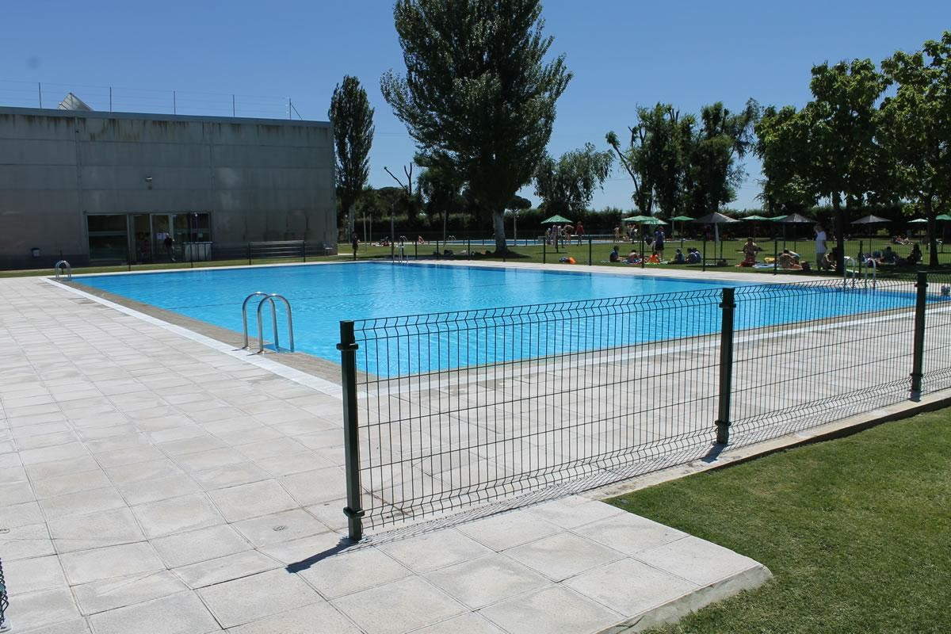

ACCOMMODATION
“RESIDENCIA DEPORTIVA DE ISCAR” Youth Hostel. Iscar, Valladolid. SPAIN. www.alberguesvalladolid.com
Accommodation, local transportation and other activity costs are covered by the hosting organization only during the project’s dates (23rd February to 3rd March 2017).
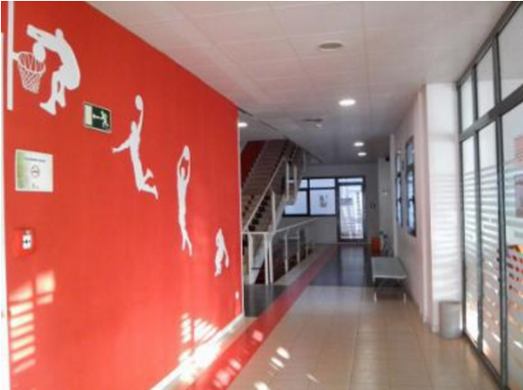
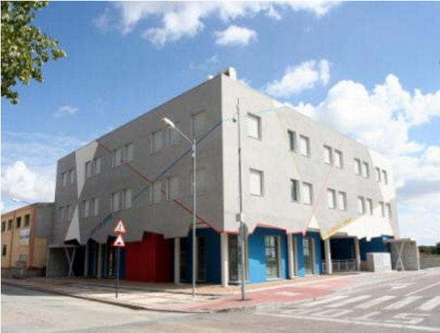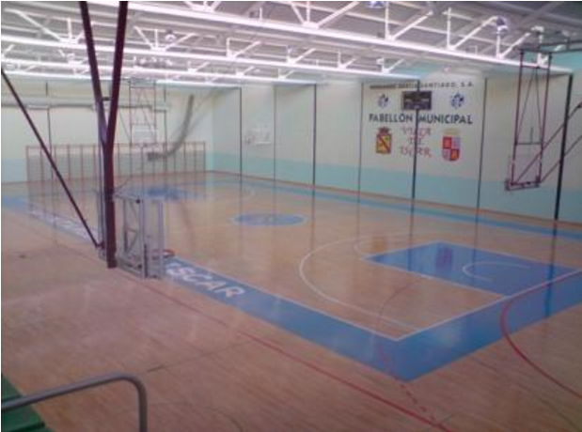

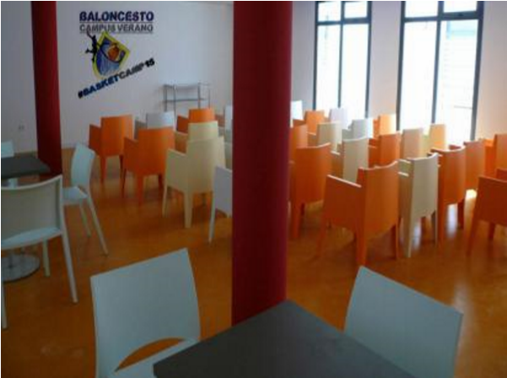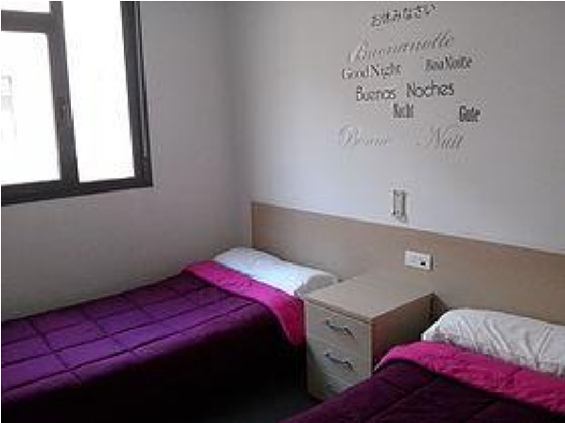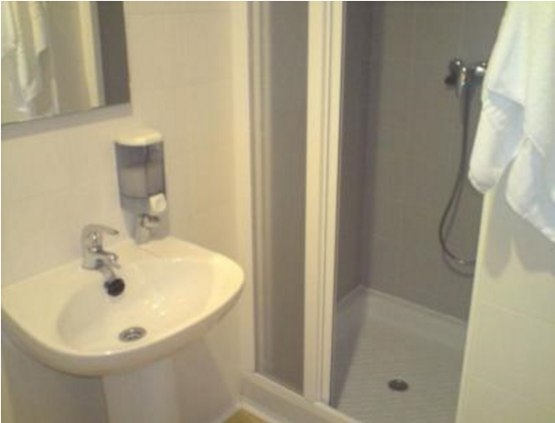

COSTS AND REIMBURSEMENT

COSTS AND REIMBURSEMENT

Condizioni economiche
- Vitto (colazione-pranzo e cena) e alloggio sono coperti al 100% dall’associazione
- I trasporti acquistati dai partecipanti verranno rimborsati a fine progetto al 100% su un massimale di spesa di 170 euro (la percentuale è calcolata sempre sul quel massimale. Spese superiori sono a carico del partecipante)
- Quota di partecipazione: 50 euro
La quota va pagata SOLO dopo essere stati selezionati

”Feedback is coming”, Youth Exchange Project is implemented with financial support from the European Commission and the ERASMUS+ Programme. Accommodation, food, as well as activities costs will be covered from the project budget. It is recommendable to get travel insurance but it will not be covered by the project budget.

All participants must consult with the organizers on prices & routes (please contact europalmente@outlook.it), before buying any tickets.
Travel expenses will be covered after collecting travel documents on condition that the participants use the cheapest ways of transportation and submitted original invoices for plane tickets, boarding passes, train and bus tickets. Private cars, Taxi and first class tickets will not be reimbursed.
Please keep the boarding passes from your airport check in as well. Reimbursement will be done in EURO, regardless of the currency indicated on your ticket and receipt/invoice. Please note if you bought your ticket in your local currency which might be different than EUR, we will calculate your travel costs according to the exchange rates from official European Commission web-site, on the day of the purchase
http://ec.europa.eu/budget/inforeuro/index.cfm?Language=en

!! Note: Please make the copies (better scan or take photographs) of your tickets and invoices before you will come to our Youth Exchange. Email those to us myemotionsmysuccess@gmail.com as soon as you buy them. If you have tickets and invoice, make sure that you e-mailed copies of both.

TRAVEL COST
This amount is different for each country and shouldn´t be exceed. in case of exceeding the maximum allowed, the refund will be made with the maximum amount fixed for each person by country, never larger.

We will inform you about your travel limit costs once the Project is approved and the countries will be participants. Mileage calculated with the official program tool.
http://ec.europa.eu/programmes/erasmus-plus/tools/distance_en.htm

Country | Distance in kilometers from | € per participant
NORWAY | Olsvik – Medina del Campo 2469.19 km | 270 EUR
ITALIA | Zafferana etnea- Medina del Campo 1760.26 km | 170 EUR
RUMANIA | Shitu – Medina del Campo 2525.78 km | 270 EUR
PORTUGAL | Braga – Medina del Campo 293.46 km | 80 EUR
FRANCE | Estrasborg – Medina del Campo 1280.24 km | 170 EUR

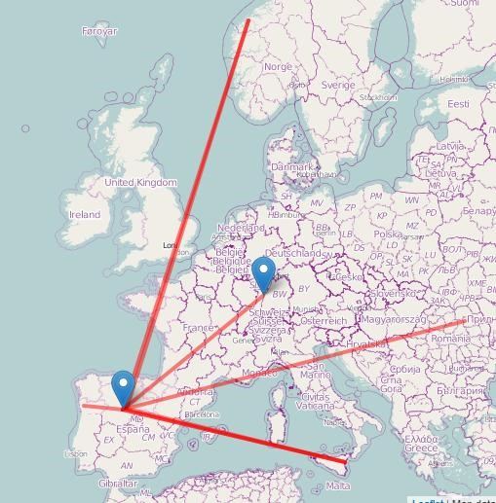

These are the cost official the new program detailing the maximum cost per participant, but the obligation of the participating associations according to the criteria of the program is to find the cheapest flight at the right time.
You should take a flight to Madrid airport, as it is the main airport near our region and are easily planes of his country.
About transportation from the airport, we will inform after collecting flight information of all participants, as they usually collect participants at the airport and take you directly to our project site together by a private bus hired by the organization.
Of course, if you want you can stay 2-3 days before/after the project in order to visit us, our Capital city, but you have to pay by yourself for those extra days.

HEALTH AND TRAVEL INSURANCE

Health insurance is not provided and will not be reimbursed by the organizers. All participants are strongly advised to purchase private travel insurance.

CULTURAL NIGHT

Don’t forget to bring some traditional music for the intercultural evenings!
We will have 6 cultural nights where we can expose ours customs, cuisine and culture., please !!! all teams must prepare some presentation of your country in a creative way (try to avoid PowerPoint and movies from tourist agencies). We hope, that your culture means you something more than national food and drinks. Also bring flag or your country. It would be nice if you bring also some small souvenirs with you (costs are not covered).

Here are a few examples from our past projects to trigger your imagination:

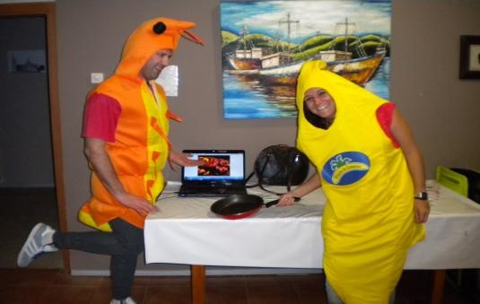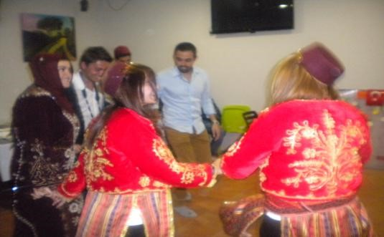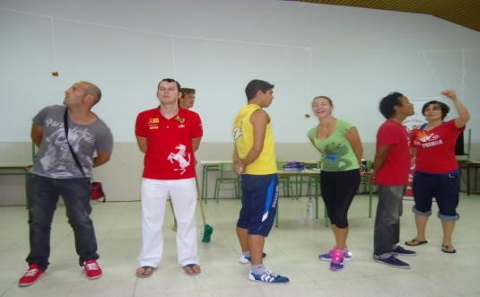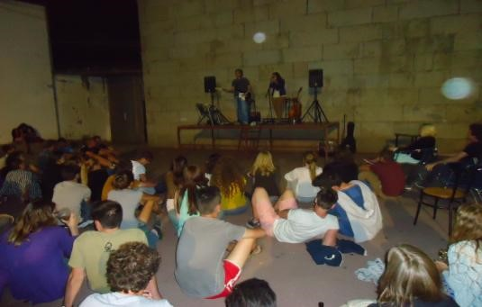

CONTACT

If you need help, have questions or need further information please contact via e-mail:

europalmente@outlook.it

Thanks for your interest!!!!

