[A PENCIL, SO MANY CULTURES

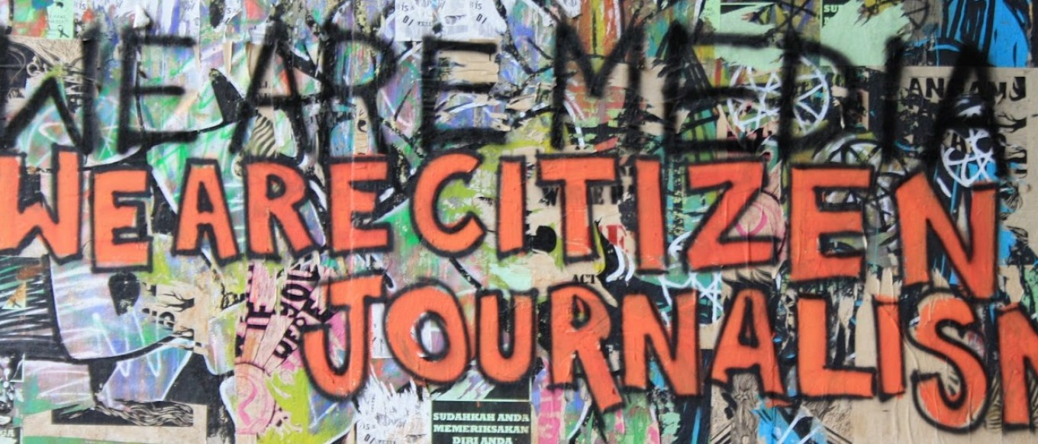A EUROPE, SO MANY WORLDS] [ERASMUS+ PROGRAMME KA1 Youth Exchange]

BOLOGNA, ITALY

28 th April – 08th May 2017

If you received this info pack that means you are one of the lucky participants who will participate to the Youth Exchange that will take place in Emilia Romagna (Italy) from 28 April to 08 May 2017.

So, in order to spice up your curiosity we will give some information about our Region in general, the venue place of the activity and what the project is all about, so you can prepare yourself for an intense and exciting week.

Should you have any questions, suggestions, problems or proposals, please do not hesitate to contact us at any time.

Looking forward to meet you soon,

*PASSI Team*

[Something about us]

PASSI cooperative enterprise is a young cooperative run  by  youth  aged  under  35  years

old  in December  2012.  We are a  project  planning  and

fundraising strategy consultancy working with profit  and  no profit

organizations in  Italy  and  abroad.  We advocate for  using  a  participatory

approach to  promote  sustainable  change,  to  connect  people  and

countries, to  boost  synergies between profit and no profit organizations in reaching shared goals. PASSI consult on European Union  funding,  application procedures, needs assessment,

technical requirements, feasibility, and  grant  writing.

Once funding is secured, we  assist  with  financial  monitoring, reporting  and  dissemination.

We use Project Cycle Management to identify opportunities, engage stakeholders, deliver actionable and  quality  results  for  our  partners  and  clients. We design  mid  and  long  term  fundraising  strategies  combined  and  connected  to

organization activities and projects. We design and implement project specific campaigns.

PASSI  support the  internationalization  of  for  profit  organizations  in

Mozambique  and  in  South Africa  through the  promotion  of  international

cooperation  and  development  programs.  We  share  our  expertise

through  tailored  skills  and  learning  solutions.

We  advocate  for  using  a  participatory approach  to  promote  sustainable

change, to  connect  people  and  countries,  to  boost  synergies between

profit  and  non-profit  organizations  in  reaching  shared  goals.  PASSI

consult  on European  Union  funding,  application  procedures,  needs

assessment,  technical requirements, feasibility,  and  grant  writing.

Once  funding  is  secured,  we  assist  with  financial  monitoring, reporting  and  dissemination.  We  use  Project  Cycle  Management  to

identify  opportunities, engage  stakeholders,  deliver  actionable  and

quality  results  for  our  partners  and  clients.

We design  mid  and  long  term  fundraising  strategies  combined  and

connected  to  organization activities  and  projects.

We  design  and  implement project  specific  campaigns.  PASSI  support the  internationalization  of  for  profit  organizations  in  Mozambique  and  in  South  Africa  through the  promotion  of  international  cooperation  and  development  programs.

We  share  our  expertise through  tailored  skills  and learning  solutions.

We  believe  in  a  reality  in  which  all  individuals  would  be  aware  of  their  own  dignity,  have equal  opportunities  to  develop  their  standards  of  life

and  feel  free  to  plan  a  future  made  of opportunities  and

auto determination.

PASSI  works  combing  formal  and  non formal  methodologies  promoting  the  youth  active participation  using  a  new  approach that  combine  the  Goal  Oriented  Project  Planning

and  the methodologies  of  the  Theatre  of  Oppressed  of  Augusto  Boal.

We work to help the communities  to  internally  develop  a  positive  and  constructive  energy. Such a energy should  allow  people  to  reactivate  their  creativity,  to  have  their  claims  heard,  to negotiate  their  own  needs  and  to  pursue  their  own

wishes.  PASSI  is  involved  in  different  youth  capacity  building  activities  located  both  in  Italy  and Africa  (South  Africa,  Mozambique,  République  Démocratique  du  Congo,  Kenya).

PASSI together with its customers and partners, are trying to promote activities to

stimulate the creative empowerment of young people and their entrepreneurship.

The aim of the PASSI is to empower youth organizations accompanying them in the realization of theirs objective, providing them with knowledge, skills and competencies in project cycle management, fundraising strategies, communication skills and help

young to improve the opportunities for them to actively participate in defining the future policies of their territory.

[Project Summary]

ADVANCE PLANNING VISIT

27-30 March 2017

Venue: Bologna, Italy

Working Language: English

Participants: 1 Participant (17-23 years) and 1 Group Leader (28-34 years old, exceptionally up to 34 years old) per Country.

The Group Leader must be the same who will accompany the participants during the exchange, exceptional case should be communicate in time.

The questions to be discussed during the Advance planning visit include:

1. Organizations - Sharing experience/presenting organizations/Program aspects

* Detailed description of the participants who have been selected, character traits, CV, experience, backgrounds, special needs, religion, diet, allergies etc. (profile, contacts, emergency, health/dietary needs, gender balance)
* Reviewing agenda
* Division of tasks among groups
* Responsibilities and roles of leaders
* Reflection, definition and testing of games and exercises to be used during the exchange activity, materials needed
* Definition of tools that participants will have to prepare before the Youth Exchange
* Knowledge meeting with all the local stakeholders who will be directly or indirectly involved in the project
* Visibility of the project - activities and tasks
* Visit of sites and venues of the project

1. Logistics/Practical matters

* Venue/hotel/food
* ravel/pick up
* Safety and insurance
* Potential challenges and issues and possible solutions
* Final list of things to prepare prior to the project, things to bring, responsibilities of leaders and groups, updated agenda.

YOUTH EXCHANGE

28 April - 08 May 2017

Venue: Bologna, Italy

Working Language: English

Participants: 5 Participant (17-23 years) and 1 Group Leader (28-34 years old, exceptionally up to 34 years old) per Country.

"A Pencil, so many Cultures. In Europe, so many Worlds." is a youth exchange project which aims to involve youngsters, aged between 16 and 25, from different parts of Europe (Portugal, Italy, Macedonia, Finland, Lithuania and Turkey) to reflect about a pro-active approach to participation in democratic life and to the cultural growth of the g-local company.

The youth exchange will last 11 days and will be realized in the Italian city of Bologna. The youngsters will came from countries with different forms and levels of active participation (such as classic political participation, associacionism, internet activism, taking part at protests or boycott), strategies and levels of integration, inclusion and other social dialogue, different historical experiences of migration, in order to share experiences and methods of participation, to enable a process of positive contamination of the more “deficient” ones and to enhance their intercultural awareness levels.

The project wants to breakdown the difficulties that European youngster encounter in overcoming cultural and language barriers and the frustration that young people feel, resulting from the overwhelming pressure from the global to the local and the continuous tension between homogenizing pressures and differentiating pressures - trend that greatly weakens the exercise of active citizenship and the building of collaborative social relationships and pro-active. The project aims to provide theoretical and practical tools to educate young Europeans to a "g-local citizenship" capable of addressing issues of global concern, with the intention of producing a progressive transformation of values, attitudes and behaviour so that acting locally is a consequence of thinking globally. Therefore, we aim to make young people playing an active role in decisions that concerns them and more responsible to community life, first of all strengthening a cooperative and rights and duties’ committed social interaction. This approach to society should be exercised at every level, daily in their life (in contexts such as family, schools, associations, peer groups) as well as, in the long run, in the political participation opportunities offered by European Union institutional framework.

We are going to achieve our purpose through the use of non-formal education, Theatre of the Oppressed practices, Comics workshops, using graphic and citizen journalism. The activities will allow the acquisition of soft skills such as critical thinking, willingness to dialogue, mediation and negotiation skills as tools of peaceful resolution of conflicts, being the intercultural dialogue system of value the necessary framework. In this way, the young people involved in the exchange, will break down preconceptions and barriers that disrupt their psychosocial development, will strength its European identity and will experience new forms of dialogue and constructive cooperation in the name of values such as democracy, tolerance, dignity and reciprocity of human rights.

This action will also benefit the approach of the youngsters in the world of work, having acquired soft skills such as greater self-awareness and of their potential, knowledge of non-verbal and Para verbal language, team-work and conflicts resolution abilities, a more profitable predisposition to social interactions.

[Organizations]

HOST ORGANIZATION

PASSI SOCIETA’ COOPERATIVA, Italy

SENDING ORGANIZATIONS

GROUP OUTPOINT, Turkey

SIRIUS, Finland

ACTIVE YOUTH, Lithuania

ARCSS, Portugal

EESTEC LC, Macedonia

[Working Methods]

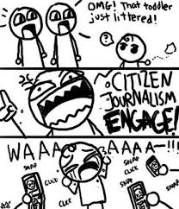The Youth Exchange is designed as a process of informal learning and peer education using participants’ own experiences in the fields of youth work and international cooperation. To be successful this will require participants to have an active input in sharing knowledge and experience, and to be willing to learn new skills from the trainers and from each other.

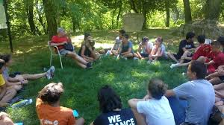The methods employed over the 11 days of the project will include:

* verbal and visual presentations
* small group discussions
* plenary debates
* game playing
* theatre of oppressed (Image Theatre and Drama Journal)
* workshop of comics and illustration
* workshop of citizen journalism
* cultural presentations

[Youth Pass]

Within the frame of ‘recognition of non-formal learning’, like participants you will receive a ‘Youth pass’ Certificate after the youth exchange.

Youth pass is an official recognized tool in order to validate non-formal learning aspects gained during the training. Through the process of receiving a Youth Pass Certificate, you will also gather information and methodologies how to implement Youth pass in your own projects.

It is important that, before coming to A PENCIL, SO MANY CULTURES. A EUROPE, SO MANY WORLDS. Youth Exchange, you reflect upon what competences you aim to develop by taking the initiative to participate to A PENCIL, SO MANY CULTURES. A EUROPE, SO MANY WORLDS. Youth Exchange.

For further information, just follow the link: <http://www.youthpass.eu./>

[Basic Rules]

* No drugs
* No alcohol drinks
* Respect of nature
* Respect of the places and spaces that will host the project
* Respect of each other
* To be on time
* The national groups should have: 3 males + 3 females;
* The project will be held in English language. The participants should have at least basic understanding of this language.

[Transportation]

Arrival is on 28 April 2017

FLIGHT: From your town to Bologna Airport.

To arrive at the project venue (Bologna, Via Bellinzona n. 6) from Bologna Airport you can use the public bus service:

* Bologna Airport -> Bologna Railway Station

<http://aerobus.bo.it/en>

From 7:00 am to 9:30 pm a bus runs between the airport and the railway station every 11 minutes. One-way ticket from/to the Airport € 6.00. Tickets can be purchased directly on this website, from the automatic vending machines located in the airport, and in Bologna at the Central Railway Station (at the Aerobus departure point) or at the TPER ticket offices.

Only tickets specifically valid for Aerobus may be used; regular TPER tickets and passes are not valid on Aerobus. A ticket is good for a single trip on Aerobus from/to the airport, and must be validated upon boarding.

The ticket can also be used on all public transport in the Bologna urban area within its 75 minutes of validity, validating it each time you board (if you want to travel on other city buses, electronic tickets must be converted before boarding. See below for further information).

* Bologna Railway Station -> Via Bellinzona n. 6

<http://www.tper.it/>

You have to keep the bus number 57 (direction RAVONE) and get off at the bus stop SAN GIUSEPPE (after 8 stops). We will be 150 meters from there.

Departure is on 08 May 2017

Note that the organisers will not provide any additional accommodation outside the

dates of the exchange! If you wish to travel on other dates than the dates of the exchange, please take contact with the organisers before purchasing your tickets!

You also may fly to Milano, Bergamo, Firenze or Venezia, sending organizations will suggest you the best solution. From whatever airport you will arrive, you should get to train station of the city and check the connection until Bologna. Here the link: [www.trenitalia.it](http://www.trenitalia.it)

Very important is that you KEEP ALL THE BILLS, TICKETS AND BOARDING PASSES from their travel, so that we were able to reimburse you the costs.

Important: Buy already the coming back ticket (bus, train, plane etc) and print twice the coming back ticket.

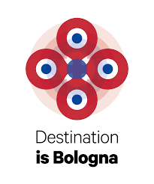[Emilia Romagna and Bologna]

Emilia-Romagna is an administrative Region of Northern Italy. Its capital is Bologna. It has an area of 22,446 km2 (8,666 sq mi), and about 4.4 million inhabitants.

Emilia-Romagna is one of the wealthiest and most developed regions in Europe, with the third highest GDP per capita in Italy. Bologna, its capital, has one of Italy's highest quality of life indices and advanced social services. Emilia-Romagna is also a cultural and tourist centre, being the home of the University of Bologna, the oldest university in the world, containing Romanesque and Renaissance cities (such as Modena, Parma and Ferrara), being a centre for food an automobile production (home of automotive companies such as Ferrari, Lamborghini, Maserati, Pagani, De Tommaso e Ducati) and having popular coastal resorts such as Cervia, Cesenatico, Rimini and Riccione.

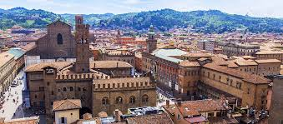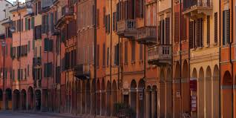Among the most creative European cities, Bologna will captivate you by offering emotions and genuineness. Take the time to visit and discover  the city, wandering and 'getting lost' through arcades, squares and market stalls, where human relationships and urban charm are inseparable. Starting from Piazza Maggiore, enclosed by the beautiful ancient palaces of Accursio, Re Enzo, Podestà and  Notai and by the majesty of Basilica di San Petronio, you will then continue your visit discovering the many towers in Bologna, and not only the “two sisters” Garisenda and Asinelli. From the top of the Asinelli tower you can admire the red roofs and the hills around the city.

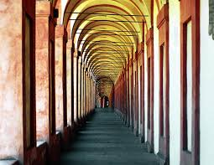Once back on the ground, you will be embraced by kilometres of arcades, the longest in the world, animated by the voices of many Italian and foreign students who attend the oldest university in Europe. When visiting the museums, you will appreciate all the history of Bologna from the Etruscan and Roman origins to its modern and contemporary artists’ paintings and writings.  Surf on **Bologna Welcome Website** to find out all information about Bologna http://www.bolognawelcome.com/en/home/

Time zone: 1 hours +GMT/UTC

Bologna has a **continental climate**, without any influence from the seaside; the Climatic Classification is ""zone E, 2259 GR/G"".

The**winters** here can be cold and snow is never lacking, sometimes it is quite abundant.  
**Summers** are hot and muggy due to the high humidity in this area, and they can be long, July and August are the hottest months, but the records tell us that sometimes in June and September maximum temperatures reached 30°C.  
**Spring and fall** are, in general, mild and rainy and quite short. Average precipitation oscillates, depending on the year, between 500 mm and more than 1000 mm and usually the 70% of precipitations are in spring or fall. Moderate wind.

Make  sure  you  take  warm  clothes.  You  can check the forecast following this link: <http://www.accuweather.com/en/it/bologna/212979/october-weather/212979>

Don’t leave Bologna if you haven’t tasted the famous and unbeatable traditional dishes as well as its cooking proposals open to the new tastes coming from different cultures. Last “but not least”, be enchanted by the magic of Bologna night life and events made of all kind of music, cinema, theater ...

[Accommodation]

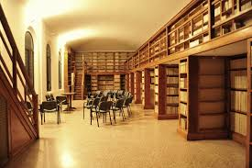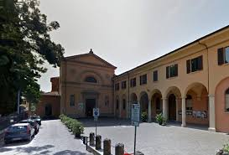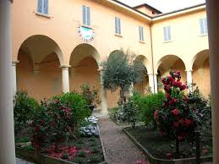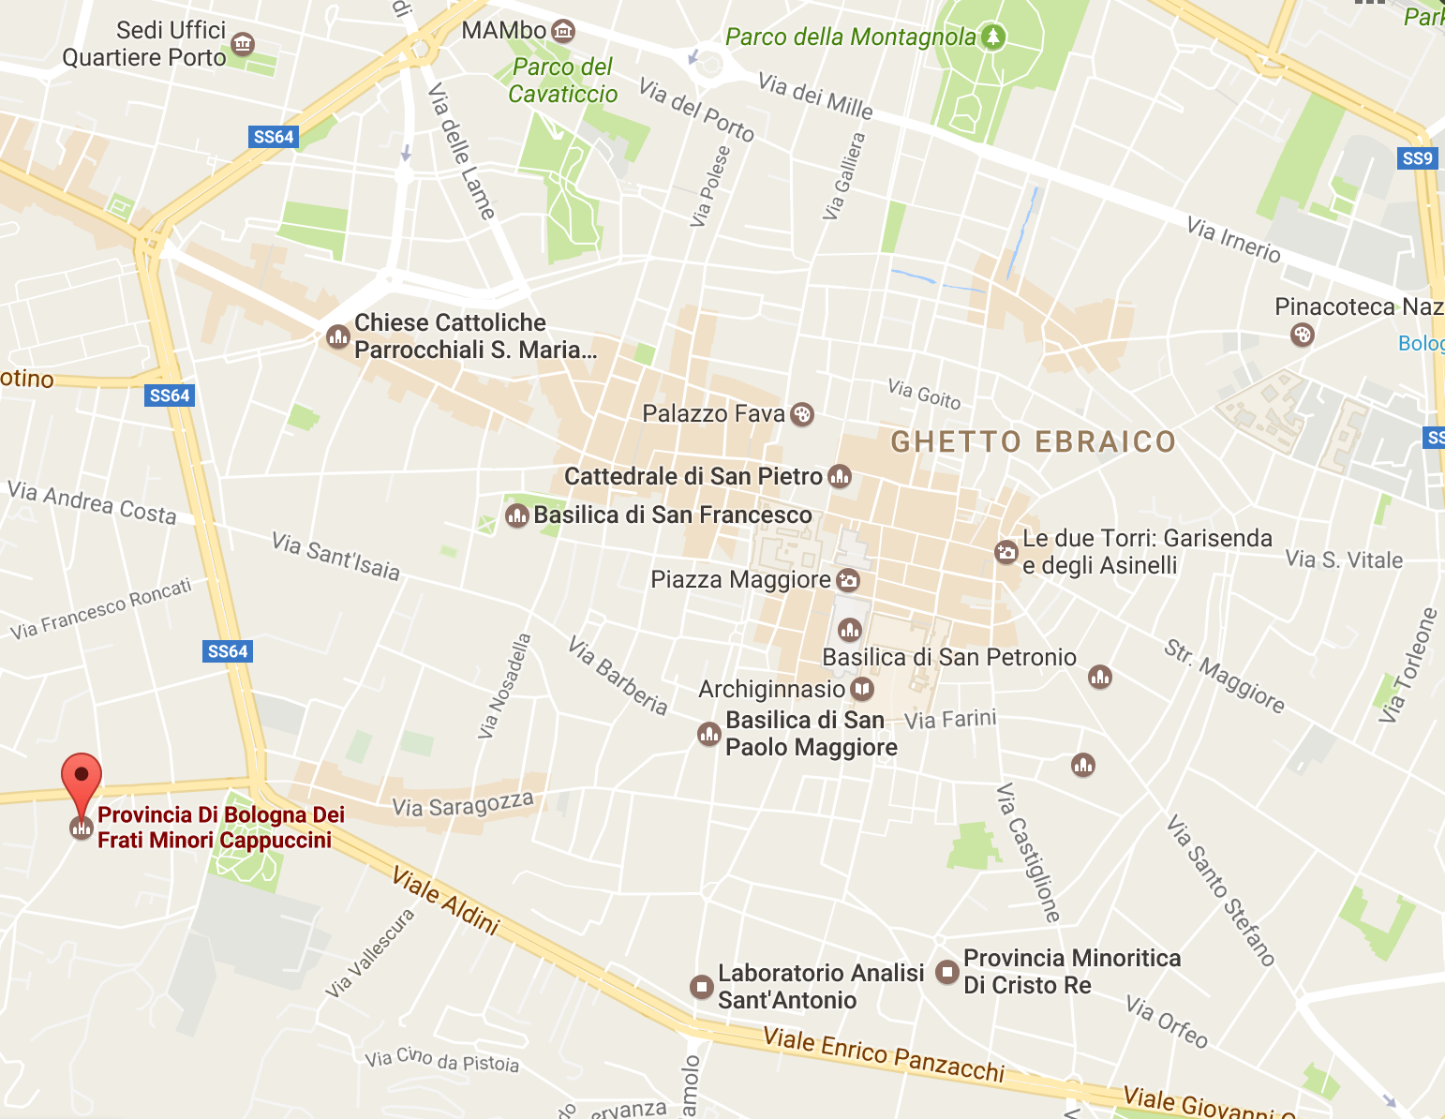The accommodation is in Bologna. You will be guests of a guesthouse run by Capuchin Friars. The accommodation is located about 2 km from Piazza Maggiore, the centre of our city.

You will be accommodated in “international” room of two or three people of same gender.

The bathrooms are shared.

The guesthouse is equipped with sheets and towels, soap, shower gel and shampoo. You must bring hair-dryers if you need it.

[Food]

The food will be prepared and served for you in our accommodation. Lunches will be prepared by a cook, while for the dinners we will define a cooking agenda and we will cooperate

to prepare the dinner. The coordinator will provide the food to participants.

We will organize for you a an aperitif and dinner out, in the city center. Please let us know if there are particular needs about the food (vegetarian, vegan, no pork meat, allergies, special diets due to medical

treatment, any other kind of health problem or particular difficulties we need to take

into account, etc.).

[Financial Matter]

Please check the table below with the information on the travel budget limits for roundtrip! If travel costs exceed the amount budgeted in the project, the organisers will only be able to reimburse participants maximum travel costs indicated in the travel budget.

|  |  |  |
| --- | --- | --- |
| MAXIMAL TRAVEL COST REIMBURSEMENT | | |
| COUNTRY | DISTANCE | TRAVEL COST FOR ONE PARTICIPANT |
| Portugal | 500-1999 | 170 Euro |
| Macedonia | 500-1999 | 170 Euro |
| Finland | 500-1999 | 170 Euro |
| Lithuania | 500-1999 | 170 Euro |
| Turkey | 2000-2999 | 270 Euro |

by bank transfer according to the rules of Italian National Agency to the Partner Organization, on the condition that the person participates during the whole youth exchange and that the person has all the bills, tickets and boarding passes (when traveling by a plane) to present to us. You must choose the cheapest way that is possible to get to Bologna (prefer travelling by Ryanair, EasyJet or Wiz air etc).

Reimbursement will be done in EUROS, regardless of the currency indicated on the ticket and receipt/invoice. Any tickets purchased in a local currency other than EURO, will then be converted and calculated according to the exchange rate of the month when the ticket/s were purchased, as stated in the official European Commission website at <http://ec.europa.eu/budget/inforeuro/>.

100% of costs of simple accommodation and basic food is covered by PASSI Società Cooperativa.

Participation fee: 100 Euros.

The fee will allow you to visit Venezia or Firenze (train tickets and food), cover the cost of cooking workshop and buy the Bologna Welcome Card 72h (guided visit to some monuments of the city, tickets to the municipal museums, affiliated dealers). <http://www.bolognawelcome.com/en/home/card>

[What to bring]

In order to everybody have a really good time, we would like you to bring some things which we believe are important for the participation of all participants and for the success of the Youth Exchange.

* a typical taste (typical drink, snacks…) of your Country for the “intercultural evening”;
* cameras, laptops and other equipment making life and work easier;
* some cool pieces of music and games from your country;
* information about your country (books, brochures, posters, postcards, video, PowerPoint presentation, music, etc.);
* information about the organization you come from (brochures, PowerPoint presentation, video, etc.);
* comfortable clothes;
* endless amounts of good mood and motivation for work and leisure!!!!

[Activities Timetable]

|  |  |
| --- | --- |
| ACTIVITY PROGRAMME | |
| TIMETABLE | ACTIVITIES |
| **28/04/2017** | |
| AM | Arrivals and accommodation participants |
| PM |
| Visit of the project spaces and participatory definition of project rules |
| 20:00 - 22.30 | Welcome Dinner + Free time |
| 22:30 - | Activities to promote mutual understanding and presentation of sending organizations and countries |
| **29/04/2017** | |
| AM 9:00 – 10:00 | Breakfast |
| 10:00 – 10:30 | Ice Breaking games + Team Building Activity+ Outdoor and trust games + Energiser + Art Counselling + Day Programme |
| 10:30 – 13:15 | * Presentation of Erasmus Plus Programme, actions, priorities, project examples, etc. * Presentation of the project objectives and program activities * Participants will explain why they are there, how they feel and what they expect. * Presentation of monitoring tools, evaluation and self-assessment, Youth Pass tool |
| 13:15 – 15:00 | Lunch + Free Time |
| PM 15:00 – 15:15 | Energiser |
| 15:15 – 17:00 | Guided by experts of communication (Moville and Cabin  Boy Studio), participants will define the logo and slogan of the project and use of communication tools at their disposal (Blog PASSInPROJECT,  Facebook and Instagram) |
| 17:00 – 17:30 | Coffee Break |
| 17:30 – 18:30 | "How was my day! “Reflection in national groups + Circle meeting Time  (Evaluation of the Day) |
| 18:30 – 19:00 | Leaders’ Meeting |
| 20:00 - | Intercultural Dinner and Night |
| **30/04/2017** | |
| AM 9:00 – 10:00 | Breakfast |
| 10:00 – 10:30 | Ice Breaking games + Team Building Activity+ Outdoor and trust games + Energiser + Art Counselling + Day Programme |
| 10:30 – 11:45 | Workshop di Citizen Journalism |
| 11:45 – 12:00 | Culture Break |
| 12:00 – 13:30 | Workshop di Citizen Journalism |
| 13:30 – 15:00 | Lunch + Free Time |
| PM 15:00 – 15:15 | Energiser |
| 15:15 – 18:00 | Workshop di Citizen Journalism |
| 18:30 – 19:15 | "How was my day! “Reflection in national groups + Circle meeting Time  (Evaluation of the Day) |
| 20:30 – 21:30 | Dinner |
| 21:30 - | Free Night |
| **01/05/2017** | |
| AM 9:00 – 10:00 | Breakfast |
| 10:00 – 13:30 | Visit of Venice or Florence |
| 13:30 – 15:30 | Lunch + Free Time |
| PM 15:30 – 19:00 | Visit of Venice or Florence |
| 20:30 – 21:30 | Dinner |
| 21:30 - | Free Night |
| **02/0572017** | |
| AM 8:00 – 9:15 | Breakfast |
| 9:15 – 9:45 | Team Building Activity + Energisers + Art Counselling + Day Programme |
| 9:45 – 11:30 | Reflection on interculturalism and pluriculturalism, work on the following concepts: relativism culture, tolerance, respect and interest in the other. Will tackle specific subjects: right-duty-reciprocity-responsibility: what are the differences between these concepts?  Such as the connections between them and with the reality that you live? We will only use Theatre of the Oppressed to stage the real life situations  daily, experience, act and reflect. |
| 11:30 – 12:00 | Culture Break |
| 12:00 - 14:00 | Reflection on interculturalism and pluriculturalism, work on the following concepts: relativism culture, tolerance, respect and interest in the other. Will tackle specific subjects: right-duty-reciprocity-responsibility: what are the differences between these concepts?  Such as the connections between them and with the reality that you live? We will only use Theatre of the Oppressed to stage the real life situations  daily, experience, act and reflect. |
| 14:00 – 15:00 | Lunch – free time |
| 15:00 – 16:30 | Cooking workshop |
| 16:30 – 17:00 | Coffee Break |
| 17:30 – 18:00 | Cooking workshop |
| 18:30 – 19:00 | "How was my day!" Reflection in groups + Circle meeting Time (Evaluation of the day) |
| 19:00 -20:00 | Leaders’ Meeting + Middle Evaluation |
| 20:30 – 22:30 | Dinner |
| 22:30 - | Free Night in city centre |
| **03/05/2017** | |
| AM 8:00 – 9:15 | Breakfast |
| 9:15 – 9:30 | Energizers + Day Programme |
| 9:45 – 11:30 | Construction of the map of relationships.  The purpose of 'activities is to highlight what are the stakeholders to which they can refer, of show them how we are interconnected with each other; exist connections between these stakeholders, such as? what kind? how to enhance them? this can be the basis of a process of construction of  g-local citizenship? |
| 11:30 – 12:00 | Gelato Break |
| 12:00 - 13:45 | We will tackle a specific subject: the interest for the difference. Using the Theatre Image, we will try to understand what is distant, strange, unusual to experiment and to fail during the cognitive process. We will work on emotions and sensations that arise and on what mean comparison, the importance of participation. |
| 13:45 – 15:00 | Lunch + Free time |
| 15:00 – 17:00 | We will tackle a specific subject: the interest for the difference. Using the Theatre Image, we will try to understand what is distant, strange, unusual to experiment and to fail during the cognitive process. We will work on emotions and sensations that arise and on what mean comparison, the importance of participation. |
| 17:00 – 20:00 | Bologna City tour |
| 20:30 – 22:00 | Aperitif and Dinner in the city centre |
| 22:00 - | Free Night in city centre |
| **04/05/2017** | |
| AM 8:00 – 9:15 | Breakfast |
| 9:15 – 9:45 | Energisers + Day Programme |
| 9:45 – 11:30 | Workshop of Fumetto muto and fumetto icone and simboli with the experts of Cabin Boy Studio |
| 11:30 – 12:00 | Cultural Break |
| 12:00 - 13:30 | Workshop of Fumetto muto and fumetto icone and simboli with the experts of Cabin Boy Studio |
| 13:30 – 15:00 | Lunch + Free time |
| 15:00 – 17:00 | Workshop of Fumetto muto and fumetto icone and simboli with the experts of Cabin Boy Studio |
| 17:00 – 17:30 | Coffee Break |
| 17:30 – 19:00 | Workshop of Fumetto muto and fumetto icone and simboli with the experts of Cabin Boy Studio |
| 19:00 -20:00 | "How was my day!" Reflection in national groups + Circle meeting Time  (Evaluation of the Day) |
| 20:30 – 22:30 | Dinner |
| 22:30 - | Free Night |
| **05/05/2017** | |
| AM 8:00 – 9:15 | Breakfast |
| 9:15 – 9:45 | Ice Breaking games + Team Building Activity+ Outdoor and trust games + Energiser + Art Counselling + Day Programme |
| 9:45 – 11:30 | We will to reflect and re-work on the things appeared during the exploration and analysis conducted in the previous days.  Salvatore Giommarresi will orient the boys in reworking of the findings of the activities of the previous days  through the use of silent comic and cartoon icons and symbols,  allow to overcome language and cultural barriers. |
| 11:30 – 12:00 | Coffee Break |
| 12:00 - 13:30 | We will to reflect and re-work on the things appeared during the exploration and analysis conducted in the previous days.  Salvatore Giommarresi will orient the boys in reworking of the findings of the activities of the previous days  through the use of silent comic and cartoon icons and symbols,  allow to overcome language and cultural barriers. |
| 13:30 – 15:00 | Lunch + Free time |
| 15:00 – 15:30 | Energizer |
| 15:30 – 17:30 | Construction, with the help of Roberto Pomi and Salvatore Giommarresi, of an advertising poster on the themes of intercultural dialogue and the role of  protagonists that young people can have in building a society and  g-local citizenship |
| 17:30 – 18:00 | Coffee Break |
| 18:00 - 19:30 | Construction, with the help of Roberto Pomi and Salvatore Giommarresi, a  Advertising poster on the themes of intercultural dialogue and the role of  protagonists that young people can have in building a society and  g-local citizenship |
| 19:30 – 20:00 | "How was my day! “Reflection in groups + Circle meeting Time (Evaluation of  the Day) |
| 20:00 – 22:00 | Dinner |
| 22:00 - | Free Night |
| **06/05/2017** | |
| AM 8:00 – 9:15 | Breakfast |
| 9:15 – 9:45 | Ice Breaking games + Team Building Activity+ Outdoor and trust games + Energiser + Art Counselling + Day Programme |
| 9:45 – 11:30 | Realization of a comic |
| 11:30 – 12:00 | Coffee Break |
| 12:00 - 13:30 | Realization of a comic |
| 13:30 – 14:30 | Lunch + Free time |
| 14:30 – 18:30 | Realization of a comic |
| 18:30 – 19:00 | "How was my day! “Reflection in groups + Circle meeting Time (Evaluation of  the Day) |
| 20:30 – 22:00 | Dinner |
| 22:00 - | Free Night |
| **07/05/2017** | |
| AM - 8:00-9:30 | Breakfast |
| 9:30 - 10:00 | Through theatrical games it will close the job |
| 10:00 - 11:00 | Self-evaluation of interactive gaming activities and group dynamics - theatre games - art counselling |
| 11:00 - 11:30 | Coffee Break Coffee Break |
| 11:30 – 13:00 | Self-evaluation of interactive gaming activities and group dynamics - theatre games - art counselling |
| PM - 13:00 - 14:30 | Lunch + Free Time |
| 14:30 - 15:00 | Energiser |
| 15:00 - 17:00 | Compilation of YOUTHPASS Coaching |
| 17:00 - 20:00 | Organization of the Farewell Party Group Work |
| 20:00 - | Farewell Party and delivery of Youth Pass certificates to all participants |
| **08/05/2017** | |
| 9:00 – 10:00 | Breakfast |
| 10:00 – 12:00 | Through theatrical games it will close the job  Evaluation Questionnaire |
| 12:00 – 13:00 | Collecting Photo and Video of the Project |
| 13:00 – 14:00 | Lunch |
| PM | Participants’ Departure |

[Italian and European Partners]

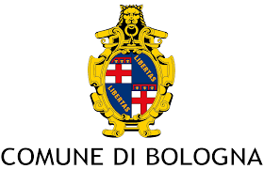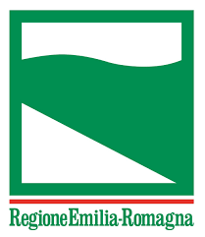**Condividi**

Facebook

Twitter

Google+

Invia per email

Fai clic per copiare il link

Tocca e tieni premuto per copiare il link

Link copiato

Ricerca tramite immagine

Le immagini potrebbero essere soggette a copyright.[Invia feedback](javascript:void(0))

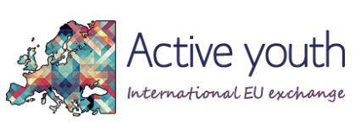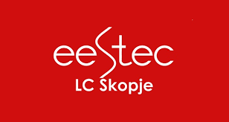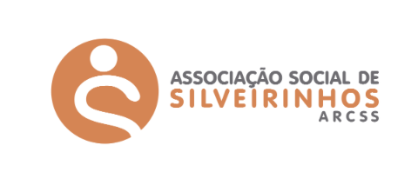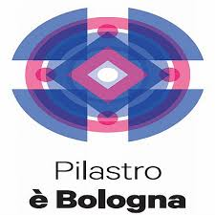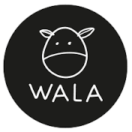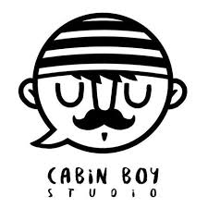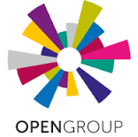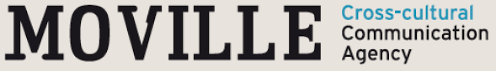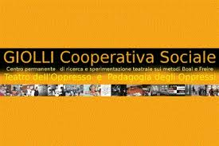

GROUP OUTPOINT

[Contact]

LAURA SANNA

Coordinator of the Project

Phone Number +393296388944

VALENTINA GIANNI

President of PASSI Società Cooperativa

Phone Number +393395629233

Phone: +3905119907636

Fax: +390510544928

Email: [info@passisocietacooperativa.com](mailto:info@passisocietacooperativa.com) - [passisocietacooperativa@gmail.com](mailto:passisocietacooperativa@gmail.com)

Website: www.passisocietacooperativa.com

Facebook Page: <https://www.facebook.com/PassiSocietaCooperativa/>

Facebook Group: <https://www.facebook.com/groups/170454566770828/>

A PENCIL SO MANY CULTURES. A EUROPE, SO MANY WOLRDS.

We wish you all nice preparations,

nice trips and we are looking forward to meet you soon!

*PASSI Team*

.